**FUNCTIONAL TESTINGS:**

1.Assertion testing

2.Gorilla testing

3.Sanity testing

4.Monkey testing

5.Smoke testing

6.Exploratory testing

7.Mutation testing

8.Benchmark tseting

**1.ASSERTION TESTING:**

**Definition:**

An **assertion** is a **boolean expression**.it is a concept of **functional testing**. It is used to test a **logical expression**. An assertion is true if the logical expression that is being tested is true and there are no bugs in the program. Assertion testing can be used at any particular stage of the program.

EX: 3<4=true, assertion true and logical expression true then their is no bugs.

7>10=false, assertion false and logical expression false then bugs are their.

**Benefits of Assertions:**

The main advantage of having assertions is to identify defects in a program. The usefulness of assertions include:

* It is used to detect subtle errors which might go unnoticed.
* It is used to detect errors sooner after they occur.
* Make a statement about the effects of the code that is guaranteed to be true.

**Limitations:**

* Failing to report a bug that exists.
* Reporting an error when it does not exist.
* Can lead to other side effects
* Can Take time to execute if it contains errors and occupies memory as well.

**2.GORILLA TESTING:**

Gorilla testing is a software testing technique that repeatedly applies inputs on a module to ensure it is functioning correctly and that there are no bugs.

**3.SANITY TESTING:**

Sanity testing is performed on stable builds and it is also known as a variant of regression testing.Sanity testing was performed when we are receiving software build (with minor code changes) from the development team. It is a checkpoint to assess if testing for the build can proceed or not.

In other words, we can say that sanity testing is performed to make sure that all the defects have been solved and no added issues come into the presence because of these modifications.

**4.MONKEY TSETING:**

Monkey Testing is a software testing technique in which the tester enters any random inputs into the software application without predefined test cases and checks the behavior of the software application, whether it crashes or not. The purpose of Monkey testing is to find the bugs and errors in the software application using experimental techniques.

**5.SMOKE TESTING:**

Smoke Testing is a software testing process that determines whether the deployed software build is stable or not. Smoke testing is a confirmation for QA team to proceed with further software testing. It consists of a minimal set of tests run on each build to test software functionalities. Smoke testing is also known as “Build Verification Testing” or “Confidence Testing.”

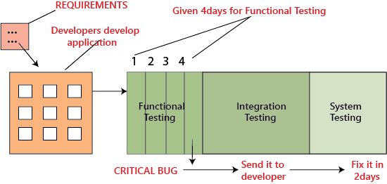

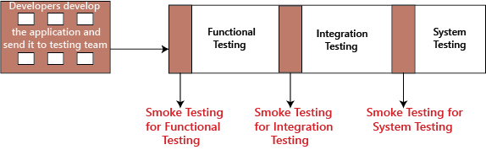

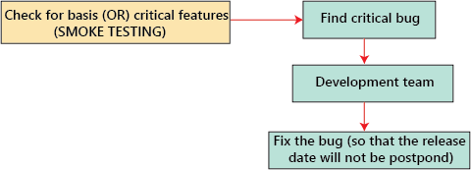

**6.EXPLORATOY TESTING:**

exploratory testing?If requirement does not exist, then we do one round of exploratory testing.So, for this first, we will be exploring the application in all possible ways, understanding the flow of the application, preparing a test document and then testing the application, this approach is known as exploratory testing.

**7.MUTATION TESTING:**

Mutation Testing is a type of software testing in which certain statements of the source code are changed/mutated to check if the test cases are able to find errors in source code. The goal of Mutation Testing is ensuring the quality of test cases in terms of robustness that it should fail the mutated source code.

**8.BENCHMARK TESTING:**

A Benchmark in Performance Testing is a metric or a point of reference against which software products or services can be compared to assess the quality measures. In other words, Benchmark means a set standard that helps to determine the quality of a software product or service.

the user experience cannot be quantified in numbers, but the time a user spends on a webpage due to good UI can be quantified.

Benchmark Testing is not a term related to just software testing, but it also deals with Hardware Testing

**# NON-FUNCTIONAL TESTINGS:**

1.Load testing

2.Strees testing

3.Usability testing

4.Performance testing

5.Volume testing

**1.LOAD TSETING:**

Load Testing is a non-functional software testing process in which the performance of software application is tested under a specific expected load. It determines how the software application behaves while being accessed by multiple users simultaneously. The goal of Load Testing is to improve performance bottlenecks and to ensure stability and smooth functioning of software application before deployment.

**Load Testing Tools:**

1. Apache JMeter

2. Web Load

3. Neo Load

4. Load Ninja

5. HP Performance Tester

6. Load UI Pro

7. Load View

**2.STERRS TESTING:**

Stress testing (sometimes called torture testing) is a form of deliberately intense or thorough testing used to determine the stability of a given system, critical infrastructure or entity. Stress testing involves testing the application under varying load. Extremely large numbers of concurrent users try to log into the application. Database linked to the website shuts down when the website tries to reach it from the front end. Data in added in extremely large quantity in the database. Stress Testing is a type of software testing that verifies stability & reliability of software application. The goal of Stress testing is measuring software on its robustness and error handling capabilities under extremely heavy load conditions and ensuring that software doesn’t crash under crunch situations.

**3.USABILITY TSETING:**

Usability testing refers to evaluating a product or service by testing it with representative users. Typically, during a test, participants will try to complete typical tasks while observers watch, listen and takes notes.

to check the usability or ease of using a software product. Checking the user-friendliness, efficiency, and accuracy of the application is known as **Usability Testing.**

**Parameters:**

Efficiency

Memorability

Accuracy

Learnability

Satisfaction

Errors

**4.PERFORMANCE TESTING:**

Performance testing is in general a testing practice performed to determine how a system performs in terms of responsiveness and stability under a particular workload. It can also serve to investigate, measure, validate or verify other quality attributes of the system, such as scalability, reliability and resource usage.

Types of Performance Testing:

• Load

• Stress

• Spike

• Endurance

• Scalability

• Volume

5.VOLUME TESTING: